LISTA DE QUADROS

| | | |
| --- | --- | --- |
| 1 | Teste Tabela. | |

LISTA DE FIGURAS

| | | |
| --- | --- | --- |
| 1 | **Mermaid** | |
| 2 | **Lorem ipsum** | |

LISTA DE SIGLAS E ABREVIATURAS

| | | |
| --- | --- | --- |
| 1 | ABNT - Associação Brasileira de Normas Técnicas; | |
| 2 | APA - American Psychological Association; | |

Hello World

# Second level heading

Lorem ipsum dolor sit amet, consectetur adipiscing elit. Sed vitae diam eget risus var (LINKED ART, 2021a).

**Figura 1: Mermaid**

erDiagram
OBJETO ||--|{ CLASSIFICACAO : ""

**Fonte:** Elaborado pelo autor.

## Third level heading

Lorem ipsum dolor sit amet, consectetur adipiscing elit. Sed vitae diam eget risus var. (LINKED ART, 2021a)

### Fourth level heading

Lorem ipsum dolor sit amet, consectetur adipiscing elit. Sed vitae diam eget risus var. (LINKED ART, 2021b)

#### Fifth level heading

Lorem ipsum dolor sit amet, consectetur adipiscing elit. Sed vitae diam eget risus var. (LINKED ART, 2021a, 2021b)

##### Sixth level heading

Lorem ipsum dolor sit amet, consectetur adipiscing elit. Sed vitae diam eget risus var.

**Figura 2: Lorem ipsum**

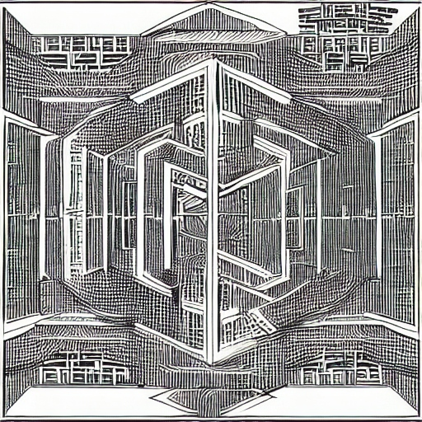

First level

Quadro 1: Teste Tabela.

| Name | ID |
| :--------- | -- |
| John Doe | 1 |
| John Smith | 3 |

Fonte: Elaborado pelo autor.

# Second level

## Third level

rock bottom.

Referências

LINKED ART. **Linked Art**. 2021a. Disponível em: https://linked.art/. Acesso em: 20 maio. 2023.

LINKED ART. **Community - Linked Art**. 2021b. Disponível em: https://linked.art/community/. Acesso em: 20 maio. 2023.